Sprint 2 – Accuracy Design Document

November 20, 2023

Table of Contents

1. Executive Summary 3

1.1 Project Overview 3

1.2 Purpose and Scope of this Specification 3

2. Product/Service Description 3

2.1 Product Context 3

2.2 User Characteristics 3

2.3 Assumptions 3

2.4 Constraints 3

2.5 Dependencies 3

3. Requirements 4

3.1 Functional Requirements 4

3.2 Security 4

3.2.1 Protection 4

3.2.2 Authorization and Authentication 4

3.3 Portability 4

4. Requirements Confirmation/Stakeholder sign-off 4

5. System Design 5

5.1 Algorithm 5

5.2 System Flow 5

5.3 Software 6

5.4 Hardware 6

5.5 Test Plan 7

5.6 Task List/Gantt Chart 8

5.7 Staffing Plan 8

# Executive Summary

## Project Overview

The current project is to test the accuracy of a Sphero Bolt Robot when performing a figure eight 5 times. Using specific software for the robot and block code, the goal is to program the robot to successfully and accurately move around in a figure eight five times without steering off of the path.

## Purpose and Scope of this Specification

The purpose of this specification is to have University Students program a robot to perform several different sprints accurately and efficiently.

In Scope

This document addresses requirements related to Sprint 2 of The Robot Project:

* Program the robot to successfully perform a figure 8 course 5 times in room HH 208.

Out of Scope

The following items of The Robot Project are out of scope:

* Sprint 1: Program the robot to circumnavigate a rectangular track.
* Sprint 3: Program the robot to run an obstacle course.

# Product/Service Description

## Product Context

This Sphero Bolt Robot is part of an entire line of other robots, such as the Sphero Sprk and Sphero Sprk+. The Sphero Bolt Robot used for this project can be controlled through block code via the Sphero Edu software. The robot has the ability to roll to specific locations at certain speeds and directions, as well as turn specific colors and speak.

## User Characteristics

* University Student
* First Year CS/SE Major
* Entry Level Programming Knowledge

## Assumptions

* Assumes the Sphero Edu software is already installed on device.
* Assumes that robot is calibrated to face the initial direction it will move in before starting program.

## Constraints

* Size of the classroom HH 208.
* Limited availability of HH 208.

## Dependencies

* Requires up to date version of Sphero EDU software.

# Requirements

## Functional Requirements

| Req# | Requirement | Comments | Priority | Date Rvwd | SME Reviewed / Approved |
| --- | --- | --- | --- | --- | --- |
| ACCUR_01 | Stay on path | Robot must stay on path during its course. | Priority 1 | 11/12/23 | Chris, Marwan, Mike |
| ACCUR_02 | Run figure 8 course 5 times. | Robot must successfully travel around the figure eight course 5 times. | Priority 1 | 11/12/23 | Chris, Marwan, Mike |
| ACCUR_03 | Start in provided square | Robot must be in the provided square before starting its course. | Priority 1 | 11/12/23 | Chris, Marwan, Mike |
| ACCUR_04 | Finish in provided square. | Robot must stop in the provided square after its course. | Priority 1 | 11/12/23 | Chris, Marwan, Mike |
| ACCUR_05 | Speak “I am the winner” at finish | Robot must speak “I am the winner” at finish. | Priority 1 | 11/12/23 | Chris, Marwan, Mike |
| ACCUR_06 | Flash multicolored lights for 5 seconds. | Robot must flash multicolored lights for 5 seconds at the finish. | Priority 1 | 11/12/23 | Chris, Marwan, Mike |

## Security

### Protection

* The main factor that protects the system from accidental access is Bluetooth connection to a specific device. A Bluetooth connection must be made to the robot to connect to it, and only one user can connect at a time.

### Authorization and Authentication

* To authorize robot use, the user must know robot name to authenticate it through the Sphero Edu Software.

## Portability

* High environmental independence
* Compatible with iOS, Android, Windows, and MacOS.

# Requirements Confirmation/Stakeholder sign-off

|  |  |  |
| --- | --- | --- |
| Meeting Date | Attendees (name and role) | Comments |
| 11/12/23 | Chris D., Marwan E., Mike M. | Confirmed all requirements. |

# System Design

## Algorithm

* Start
* Step 1: Set speed to 95.
* Step 2: Spin 360 degrees for 7.5 seconds.
* Step 3: Spin -360 degrees for 7.5 seconds.
* Step 4: Loop Steps 2 and 3 5 times.
* Step 5: Set speed to 0.
* Step 7: Speak “I’m the winner.”
* Step 8: Fade from (255,0,0) to (0,255,0) for 3 seconds.
* Step 9: Fade from (255,255,0) to (0,0,255) for 3 seconds.
* Step 10: Stop
* Done.

## System Flow

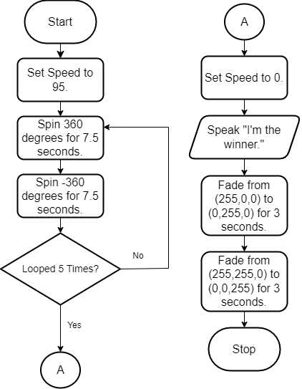

## Software

The software used for this project was block code in the Sphero Edu application.

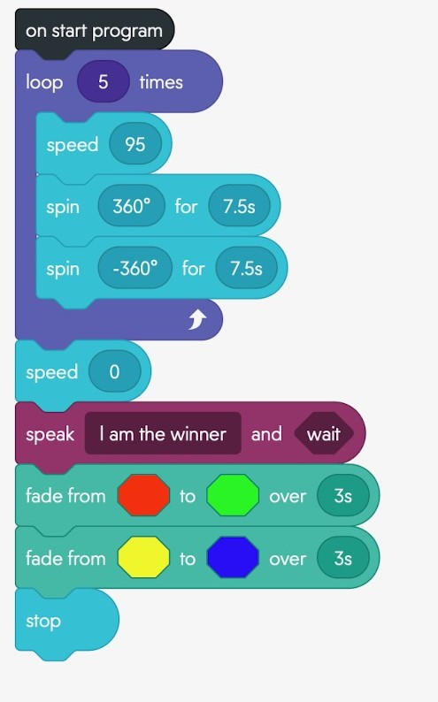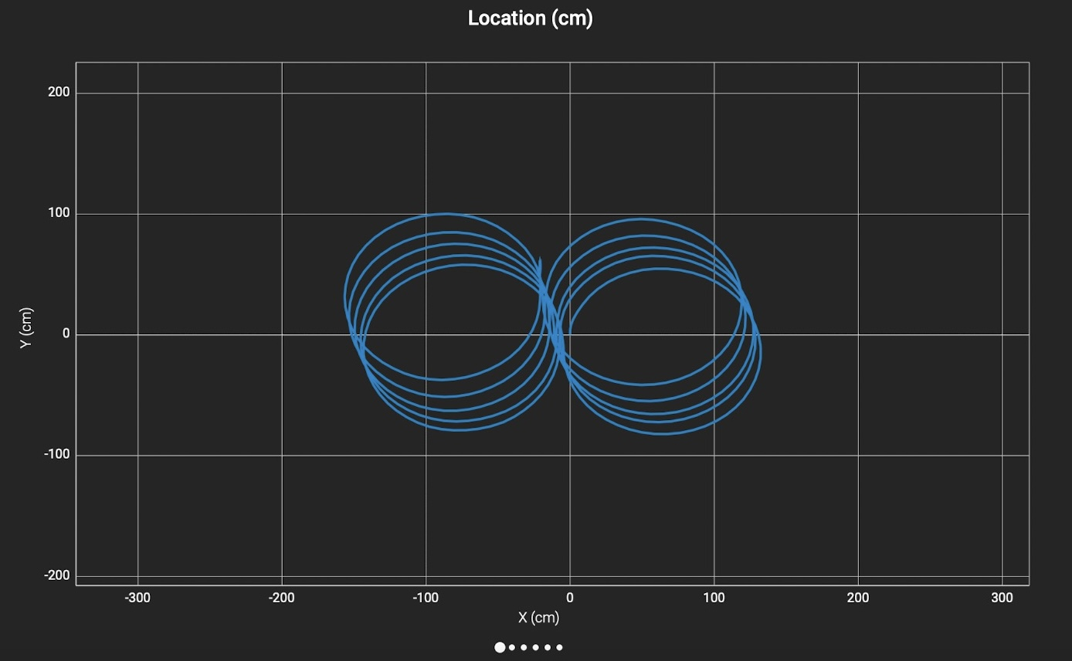

## Hardware

Hardware platforms used:

* Apple MacBook Air
* Apple iPhone
* Sphero Bolt.

## Test Plan

| **Reason for Test Case** | **Test Date** | **Expected Output** | **Observed Output** | **Staff Name** | **Pass/Fail** |
| --- | --- | --- | --- | --- | --- |
| Test if Robot successfully spins around the first circle. | 11/16/23 | Robot goes around the first circle accurately. | Robot did not complete a full circle, and was inaccurate | Chris, Marwan, Mike | Fail |
| Test if Robot successfully spins around the first circle. | 11/16/23 | Robot goes around the first circle accurately. | Robot successfully completed the full circle. | Chris, Marwan, Mike | Pass |
| Test if Robot successfully spins around the first and second circle. | 11/16/23 | Robot goes around both circles accurately in a figure 8. | Robot went around the first circle accurately, then did not complete the other circle. | Chris, Marwan, Mike | Fail |
| Test if Robot successfully spins around the first and second circle. | 11/16/23 | Robot goes around both circles accurately in a figure 8. | Robot successfully went around both circles accurately in a figure 8. | Chris, Marwan, Mike | Pass |
| Test if Robot loops the circle 5 times in a row. | 11/16/23 | Robot goes spins around the figure eight 5 times. | Robot successfully spun around the figure eight 5 times. | Chris, Marwan, Mike | Pass |
| Test if Robot speaks “I’m the winner” when finished with the figure 8 loop. | 11/16/23 | Robot speaks “I’m the winner” after the 5 figure eight loops. | Robot successfully spoke “I’m the winner” at the end of the figure 8 loop. | Chris, Marwan, Mike | Pass |
| Test if Robot flashes multicolored lights for 5 seconds. | 11/16/23 | Robot flashes multicolored lights for 5 seconds. | Robot successfully flashed the multicolored lights for 5 seconds. | Chris, Marwan, Mike | Pass |

## Task List/Gantt Chart

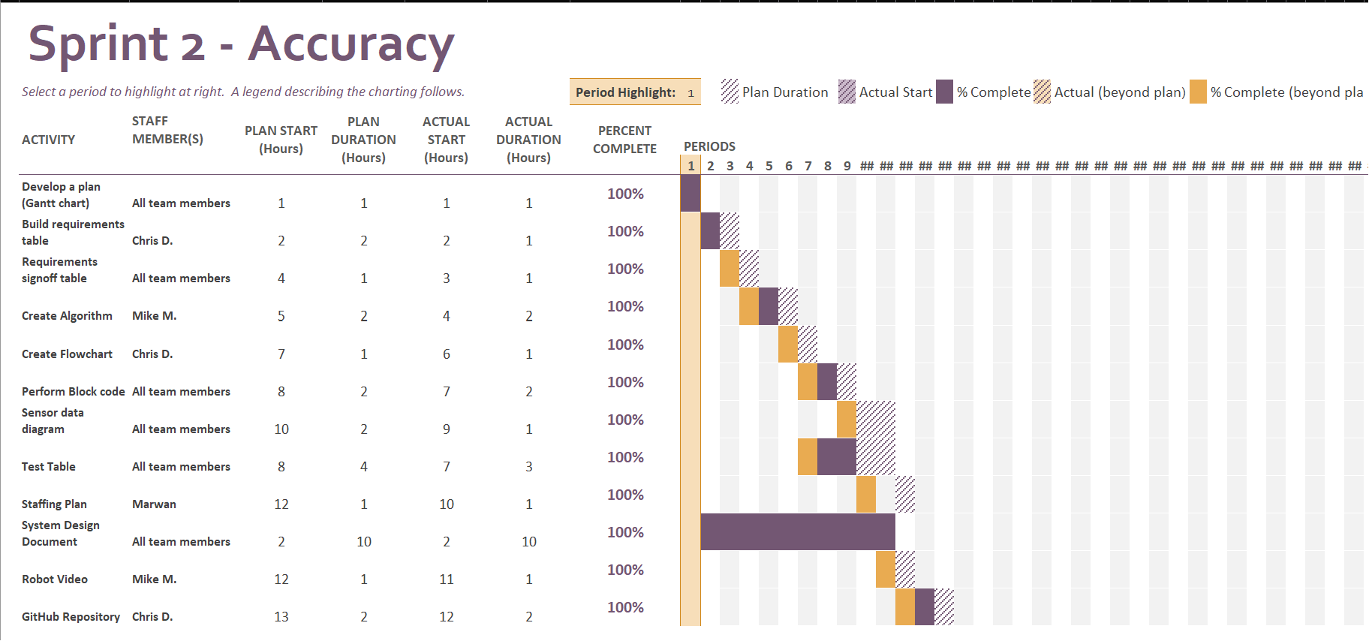

## Staffing Plan

| Name | Role | Responsibility | Reports To |
| --- | --- | --- | --- |
| Chris DeTullio | Group Member | GitHub Repository Owner, Flowchart, Requirements Table | Mike and Marwan |
| Marwan Elgoghel | Group Member | Staffing Plan, Test Table | Chris and Mike |
| Mike Montulet | Group Member | Algorithm, Robot Video | Chris and Marwan |